

**Jewellery Production Order System**

**Software Requirement Design**

– HCM, July 2024 –

**Table of Contents**

1. Overview
2. Functional Requirements
3. Database Schema
4. Database Schema
5. Table Detail

### **I.Overview**

#### 1.Product and Usage Environment:

The Jewellery Production Ordering System is a new software system that replaces the current manual directly at shops for ordering and picking up jewelry. The system is expected to evolve over several releases, ultimately connecting to the Internet ordering services to payment online.

**Users:**

**●**  **Customers:** End users who can successfully place orders online by selecting a design and customise jewellery details.

● **Sales Staff:** Sales staff who will receive requirements from customers, confirm, quote a price for customers, and handover the product to the customer.

● **Design Staff:** Design staff who will receive requirements from customers after accepting the price, upload the 3D design based on what customers require.

● **Managers**: Managers who can evaluate customer requests and give prices to sales staff, manage the order and manage the price for material.

● Administrators (Admin): Administrators have access to management, company design management, and view dashboard.

**Known Constraints, Assumptions, and Dependencies Known Constraints**

1. *Internet Connectivity:* The system relies on a stable internet connection for customers and store staff to access the platform and perform necessary actions. Any disruptions in internet service can hinder the system's functionality.
2. *Customization Limitations:* There are predefined limitations on the types of customizations available for different jewellery pieces. For instance, not all design features may be applicable to all types of jewellery (e.g., certain gemstones or engravings may only be available for specific types of rings or necklaces).
3. *Processing Time:* The time required for designing, approving, and manufacturing custom jewellery may vary significantly depending on the complexity of the request. This can affect the overall delivery timeline.
4. *Payment Security:* Ensuring secure online payment processing is critical. The system must comply with standard security protocols to protect customer payment information.
5. *User Authentication:* Robust authentication mechanisms are required to ensure that only authorised users can access and modify their profiles and orders.

**Assumptions**

1. *User Proficiency:* It is assumed that users (both customers and store staff) have a basic level of proficiency in using web-based applications to interact with the system.
2. *Scalability:* The system is assumed to be scalable, handling increasing numbers of users and orders as the business grows.
3. *Integration with Existing Systems:* The system will integrate seamlessly with existing inventory and order management systems within the store to ensure data consistency and accuracy.
4. *Customization Preferences:* Customers have clear ideas of their customization preferences and can effectively communicate their requirements through the system's interface.
5. *Compliance with Regulations:* The system is designed to comply with all relevant regulations regarding online sales, data protection, and payment processing.

**Dependencies**

1. *Third-Party Payment Gateways:* The system depends on third-party payment gateways for processing online payments securely and efficiently.
2. *Design and Production Tools:* The system relies on specific design and production tools/software used by the design and production staff to create custom jewellery.
3. *Material Availability:* The availability of materials (e.g., specific gemstones, metals) is crucial for fulfilling custom orders. Any disruptions in the supply chain can affect order fulfilment.
4. *Customer Support Services:* Dependence on customer support services to handle inquiries, complaints, and assistance throughout the ordering process. Adequate training and resources are required to support these functions.

| **#** | **Entity** | **Description** |
| --- | --- | --- |
| 1 | Requirement | This entity interacts with design, Payment, Customer, Staff, Manager. Will cover the custom design of the customer and the manager will check the requirement and lead to price. Design/ Production Staff receive the requirement and Draw/Machining and keep update status in requirement. Also contain the payment entity. |
| 2 | Design | This entity contains image, design name, and weight material, also include requirement and type of jewellery, main entity to interact |
| 3 | Master Stone | This entity represents the master stone on the jewellery, a type of jewellery can have zero or one master stone embedded in it depending on the design. |
| 4 | Stones | This entity represents stone, a type of jewellery that can have zero or more stones embedded in it depending on the design. |
| 5 | Staff | This entity represents Production staff and design staff. Receive requests from customers via manager check. Update status of product |
| 6 | Sale Staff | This entity contacts with customer and manager to send quote for manager and in charge of payment for customer, chat with customer |
| 7 | Type of jewelry | This entity represents the type of jewellery, in our system there are only 3 types: rings, necklaces, earrings |
| 8 | Customer | Role of this entity are view product, blog list, create order, choose many option to change the feature on jewellery, tracking status of product in Order, in charge of Payment of order |
| 9 | Payment | This payment represents to show the payment method, amount, what time to create a transaction |
| 10 | Manager | This entity represents the store's manager role, with the role of operating operations such as managing material prices, posting designs to the system, and quoting prices for requirements. |
| 11 | Blog | This entity represents blog posts posted by manager |
| 12 | Material | This entity represents the store's jewellery materials, including gold |
| 13 | Warranty Card | This Entity contain the information warranty policy |

#### 3. Context Diagram

**Role Guest**: Guests are unregistered users who can browse the system or application without logging in. They typically have limited access to features and functionalities, such as viewing product listings or basic information.

**Role Customer**: Customers are registered users who can browse products, place orders, and manage their accounts. They have access to features such as order history, payment methods, and personal preferences

**Role Sales Staff**: Sales staff are users responsible for managing sales-related activities, such as processing orders, handling customer inquiries, and managing product inventory. They have access to features such as order management tools, customer communication channels, and sales analytics

**Role Design/Production Staff**: Design/Production staff are users responsible for managing Product activities, such as updating status of the product, check notification, check task. They have access to features such as customer communication channels.

**Role Manager**: Managers are users with supervisory roles responsible for overseeing various aspects of the business operations. They have access to features such as employee management, sales performance analysis, and administrative controls

**Role Admin**: Admins are users with full administrative privileges and access to all features and functionalities of the system or application. They have the authority to manage user accounts, configure system settings, and perform system maintenance tasks.

#### 4.  Use Case Diagram

#### 5.  Process flow

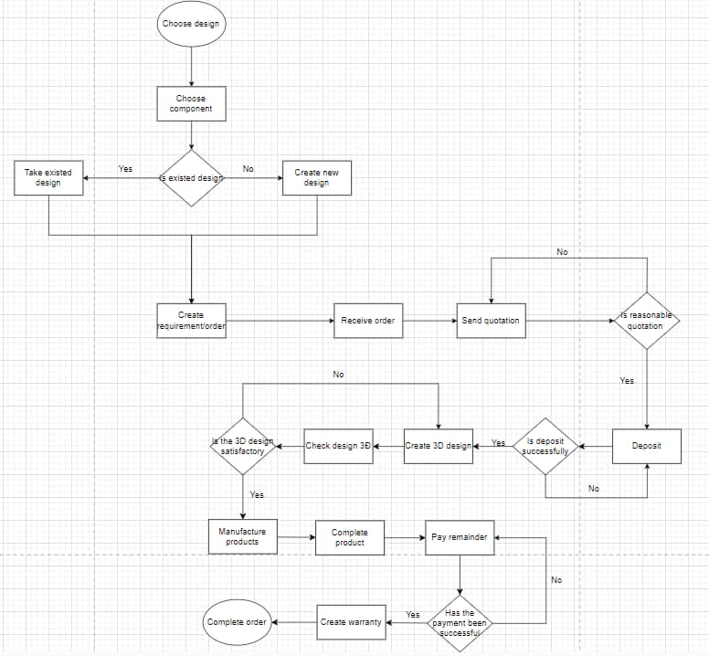

#### 6.  State Transition Diagram

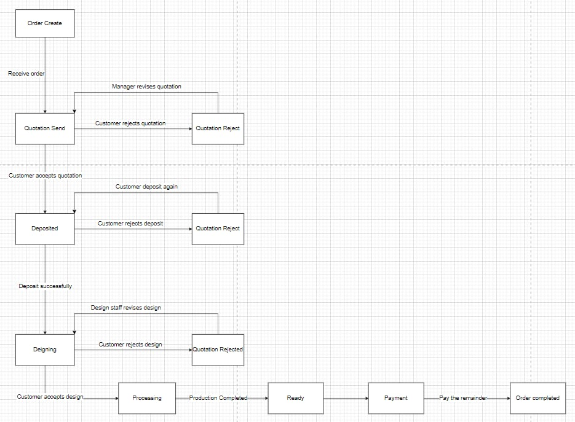

### **II.Functional Requirements**

| **ID** | **Use Case** | **Actor** |
| --- | --- | --- |
| UC - 01 | Sign up | Guest |
| UC -02 | Sign in | Guest, Customer , Staff , Admin, Manager |
| UC - 03 | Log out | Customer , Staff , Admin, Manager |
| UC - 04 | View Blogs | Guest, Customer |
| UC - 05 | View Design List | Guest, Customer |
| UC - 06 | View Design Details | Guest, Customer |
| UC-07 | Select Design | Customer |
| UC - 08 | Create Custom Design | Customer |
| UC - 09 | Get a Price For Design | Customer |
| UC - 10 | Confirm Price | Customer |
| UC - 11 | Deposit For Requirements | Customer |
| UC - 12 | View 3D Design Of Jewelry | Customer |
| UC - 13 | Confirm 3D Design Of Jewelry | Customer |
| UC - 14 | Track Order | Customer |
| UC - 15 | Pay The Rest | Customer |
| UC - 16 | View profile | Customer |
| UC - 17 | Edit profile | Customer |
| UC - 18 | Create Account Staff | Admin |
| UC - 19 | Delete Account Staff | Admin |
| UC - 20 | View Account Staff List | Admin |
| UC - 21 | Modify Account | Admin |
| UC - 22 | View Dashboard | Admin |
| UC - 23 | Create Design | Manager |
| UC - 24 | Update Design | Manager |
| UC - 25 | Delete Design | Manager |
| UC - 26 | Create Blog | Manager |
| UC - 27 | Update Blog | Manager |
| UC - 28 | Delete Blog | Manager |
| UC - 29 | Create Material | Manager |
| UC - 30 | Update Material | Manager |
| UC - 31 | Delete Material | Manager |
| UC - 32 | Create Stones | Manager |
| UC - 33 | Update Stones | Manager |
| UC - 34 | Delete Stones | Manager |
| UC - 35 | Create MasterGemStones | Manager |
| UC - 37 | Update MasterGemStones | Manager |
| UC - 38 | Delete MasterGemStones | Manager |
| UC - 39 | Update types of jewellery | Manager |
| UC - 40 | Delete types of jewellery | Manager |
| UC - 42 | View list Approval Request | Manager |
| UC - 43 | Quote for requirement | Manager |
| UC - 44 | Update 3d raft | Design Staff |
| UC - 45 | Receive Order | Sale Staff, Design Staff, Product Staff |
| UC - 46 | Send Price Request to Manager | Sale Staff |
| UC - 47 | Contact with customer | Sale Staff |
| UC - 48 | Add warranty to customer requirement | Sale Staff |
| UC - 49 | Pay in cash for requirement | Sale Staff |

### 

### **III.Database Schema**

#### 1.Database Schema

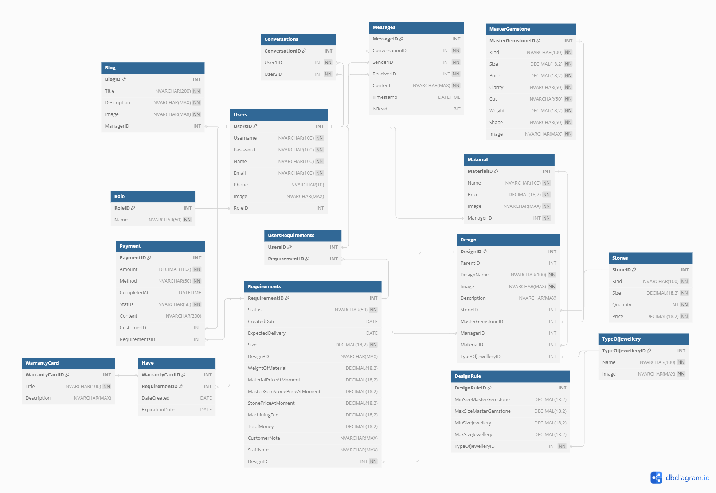

#### 2.Table description

### 

| ***Table*** | ***Description*** |
| --- | --- |
| Design | This table include all the feature need to create for the jewellery, weight and image of design |
| Requirements | The requirement created by the user to customer the jewellery like: “size”. some feature save the information involve price |
| Stones | Include the information of stones like size, quantity, kind and specification of price. This table include in Design |
| Material | Description about what kind of material like gold, silver, bronze to use |
| TypeOfJewelry | Kind of jewellery like: ring, bracelet, earring,... |
| MasterGemstone | Features need to know about master gemstones like: “Size, Cut, Shape, Weight,..” |
| WarrantyCard | Card of warranty for the jewellery |
| Have | The relationship between Requirement table and WarrantyCard |
| Payment | Tables describe the method, date complete, and who is paid, also include the requirement and price of order. |
| Blog | This table uses to attractive the guest, contain the title, description and image of blog |
| UserRequirements | The relationship between 2 tables. Requirements and User |
| Users | Contains system user information, username, password, email... |
| Role | Information about user roles, linked to the user table |
| DesignRule | Master Gemstones size rules depend on TypeOfJewelry, the size of TypeOfJewelry |
| Conversation | Save information about user's conversations |
| Messages | Save messages in conversations |